Centenary Gathering at the Lix Boulder in 2008

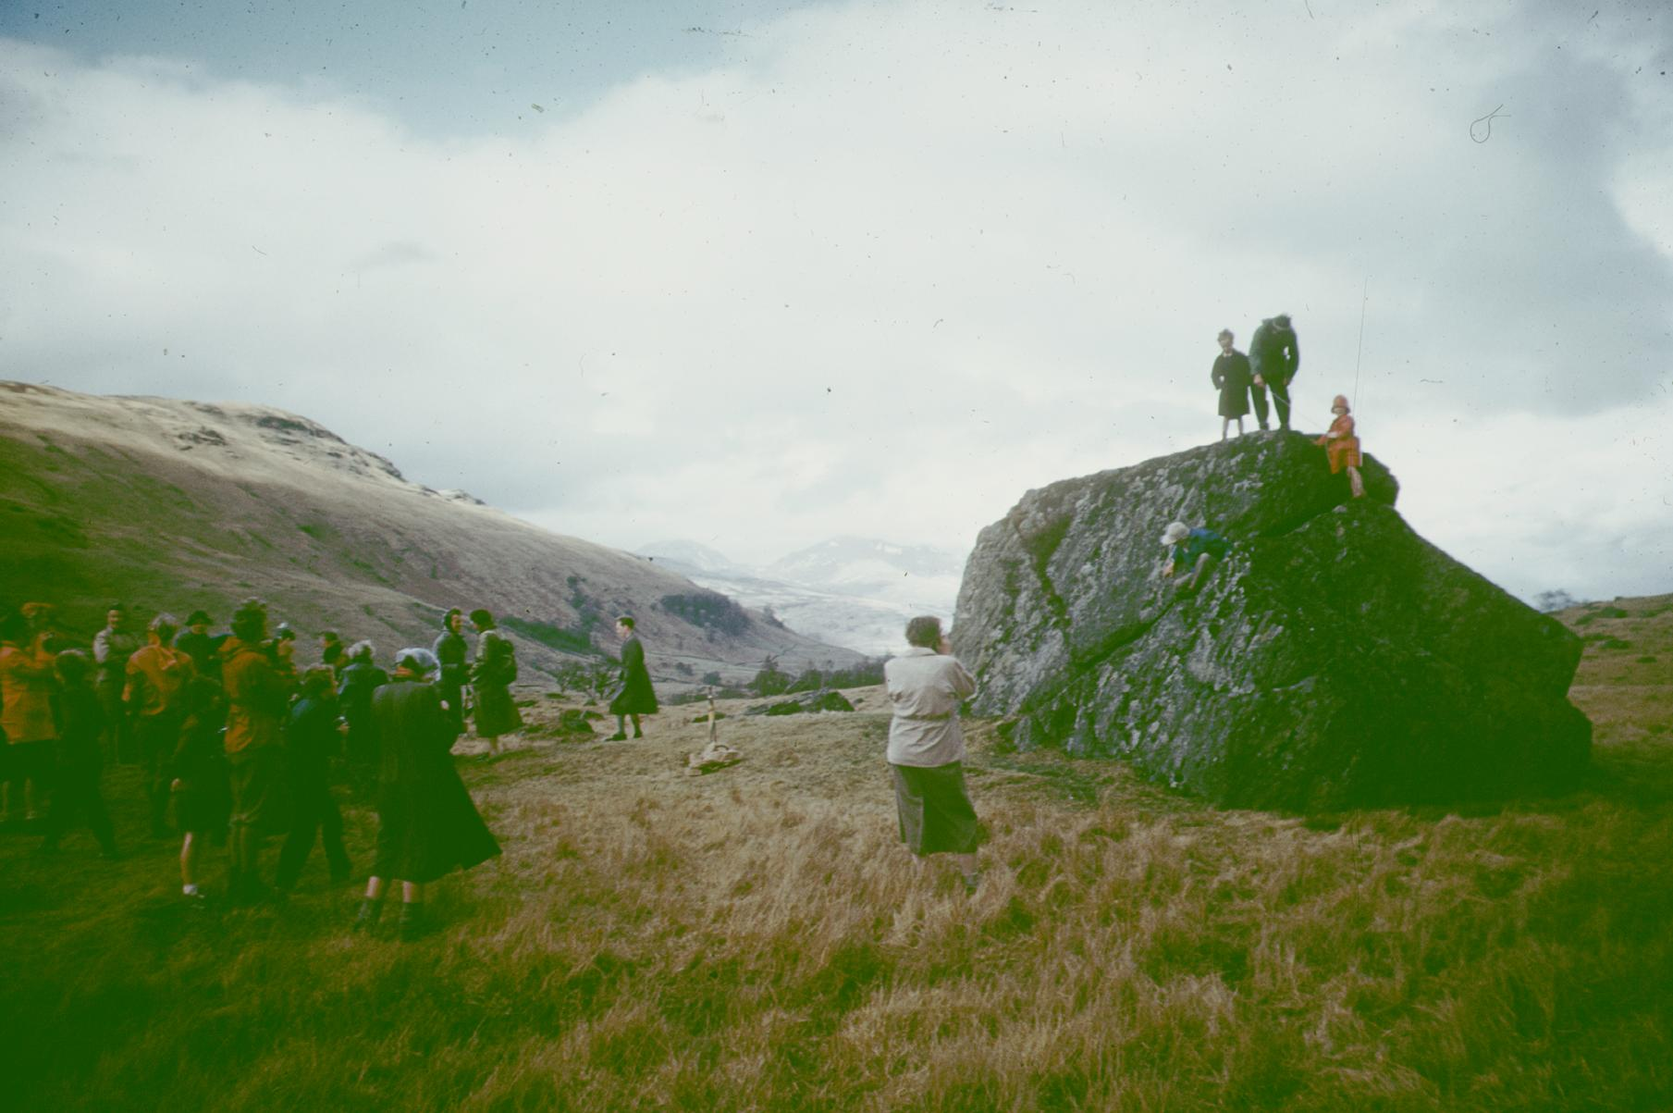
The Ladies Scottish Climbing Cub was formed by our founding members at the Lix boulder in 1908.
Lix Toll is a junction between the A85 and the A827 toward Killin. The boulder is situated about NW of this junction.
It was decided to re-visit this boulder during the centenary celebrations. However trees had been planted and had grown, as they do, and obliterated its position. The hunt was on – various members searched through rough ground. Did the previous photos help?
Eventually it was discovered, and a route established for the event.

Lix boulder in 1958 (50th celebrations) not a tree in sight!

Club members gathered, past and current Presidents climbed to the top of the boulder, as in previous anniversaries. Now notice the trees overshadowing us all.
Celebrations took place and the poem to the original Ladies was read.

Poem to the Ladies at the Boulder in 1908

None of us knows, in that seminal year
Where the Ladies had been, just why they chose here,
From that small beginning, could they ever know
How their new club would flourish, continue to grow?

Would they credit our lives, with the ease and the scope
To do what we please, for them a vain hope?
Could we face their hardships a century back
Without our ‘essentials’ we clearly would lack?

We inherit their spirit, their joys and their kinship
For the harder the challenge, the deeper the friendship.
And common to both is our love of the hills,
Which give us such pleasure, perhaps cure our ills.

On snow, rock or mountain, afar – or just here,
Wherever we gather, their spirit is there.
So here’s to the Ladies, both present and past
And to those in the future – and long may we last
Pat Brown
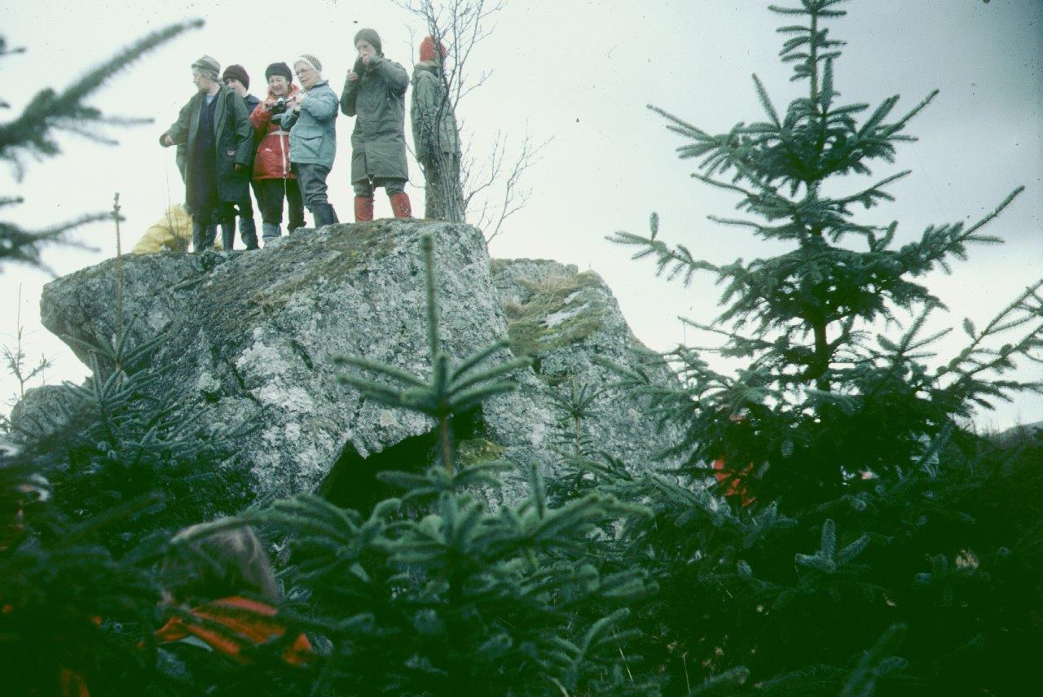

Lix boulder in 1983 (75th celebrations) the trees are growing

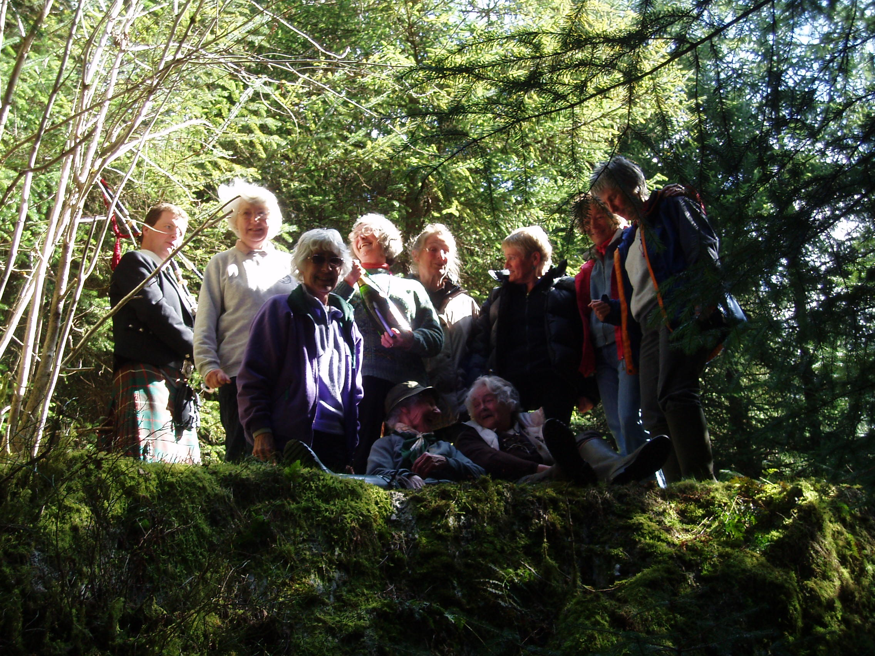

Centenary 2008 (100th celebrations) among the trees!

